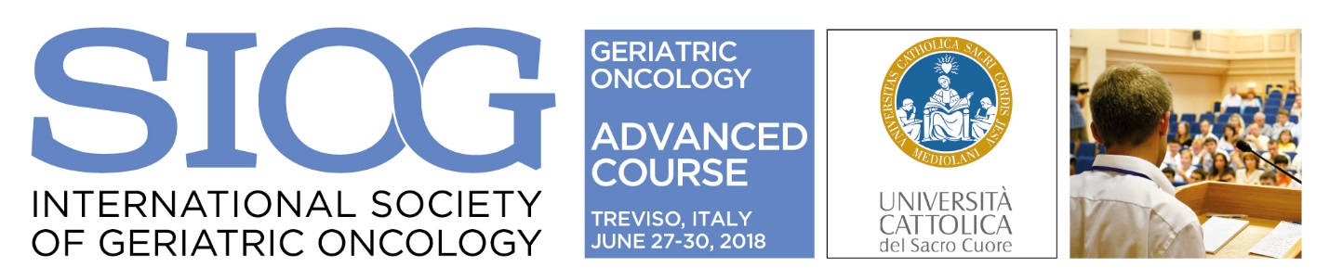

SIOG 2018 Advanced Course in Geriatric Oncology | June 27-30, 2018, Treviso, Italy

APPLICATION FORM (deadline: February 9, 2018)

Please save this file, complete it with your contact and professional details and return it electronically by e-mail (Word file) with the required documents to: events@siog.org

To complete the application, please fill in this form and return it together with the following documents:

- Motivation letter describing your intended project in the field of Geriatric Oncology within your professional activity
- Short curriculum vitae (max. 2 pages)

Only completed applications received by the deadline of February 9, 2018 will be considered.

First name: Last name:

Gender: Date of birth:

Institution name: Department:

Institution address:

Postal code: City: Country:

E-mail address*: Phone number:

* All correspondence regarding your application will be sent by e-mail.

Are you a SIOG member? Yes No

Profession:
Geriatrician
Medical oncologist
Radiation oncologist
Surgical oncologist
Radiotherapist
Palliative care specialist
Supportive care surgeon
Other:

Years in practice: Still in training 1-2 years 3-5 years Other:

Medical domain (please select from the following):
1: Solid tumours in the elderly
2: Haem malignancies in the elderly
3: Supportive and palliative care
4: Modern diagnostics and therapeutic areas

5: Geriatric assessment, nursing/allied health
and socio-economic issues
6: Other:

How would you rate your English, from 1 (basic) to 5 (mother tongue):

